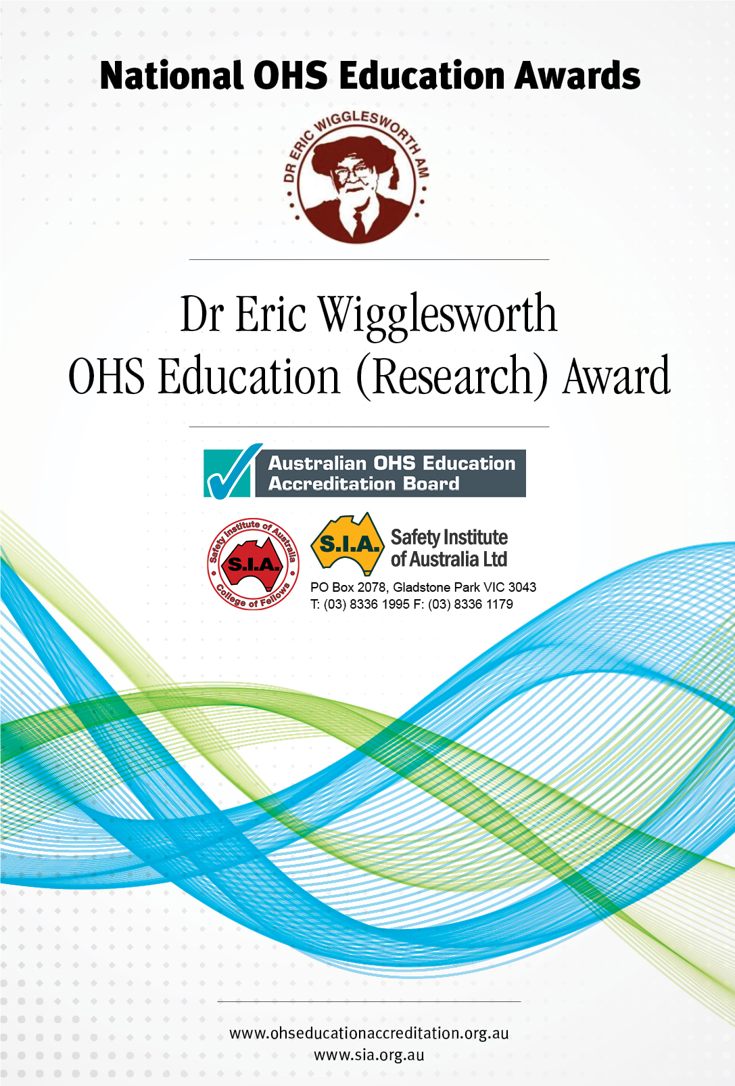

**Purpose**

Add College of Fellows logo / reference

The Safety Institute of Australia together with the Australian OHS Education Accreditation Board presents three annual education awards. The purpose of these awards is to provide an opportunity for students studying occupational health and safety at university level, and demonstrating high levels of achievement and initiative, to be recognised by the Safety Institute of Australia.

These awards are not designed to recognise the highest academic achiever, but to recognise the potential in students who display consistently high academic standards, practical skills and a commitment to, and involvement in, occupational health and safety.

In offering the OHS Education Awards it is not the intention of the Safety Institute of Australia to repeat the academic process of assessment conducted by the education institution but to provide an OHS professional perspective to educational outcomes that have already been considered exceptional by their own educational institutions.

**The Awards**

There are three awards; the Eric Wigglesworth OHS Education (Research) Award, the National OHS Education (Postgraduate) Award and the National OHS Education (Undergraduate) Award.

The national awards are presented at an annual awards event hosted by the SIA. The winners receive the following:

***Eric Wigglesworth OHS Education (Research) Award***

Commemorative medal (and certificate)

Professional Development Fund to the value of $5000

Travel and accommodation from home state to the awards presentation

Membership of the SIA for one year

Plaque to the education institution.

***National OHS Education (Postgraduate) Award***

Commemorative medal (and certificate)

Professional Development fund to the value of $2000

Travel and accommodation from home state to the awards presentation

Membership of the SIA for one year

Plaque to the education institution.

***National OHS Education (Undergraduate) Award***

Commemorative medal (and certificate)

Professional Development Fund to the value of $2000

Travel and accommodation from home state to the awards presentation

Membership of the SIA for one year

Plaque to the education institution.

This document provides information on the **Eric Wigglesworth OHS Education (Research) Awards**, information on the National OHS Education Awards is provided in a separate document.

**The Eric Wigglesworth OHS Education (Research) Medal**

The *Eric Wigglesworth OHS Education (Research) Medal* is a national award made by the Safety Institute of Australia recognising achievement in OHS education in a higher degree by research qualification in the Doctor of Philosophy, professional doctorate or masters by research. The award recognises: significant contribution to the OHS Body of Knowledge; potential for application of research outcomes in preventing work-related fatalities, injuries, disease and/or ill-health; and demonstrated dissemination of research outcomes to relevant parties.

In naming this award after Dr Eric Wigglesworth AM the Safety Institute of Australia wishes to recognise the contribution made by Dr Wigglesworth to OHS education in Australia and to the Safety Institute of Australia.

Dr Wigglesworth came to Australia in 1962 to join the Australian Defence Scientific Service as Safety Officer in Melbourne. He later became the Director of the Injury Research Project located in the Royal Australasian College of Surgeons. He was the Executive Director of the Menzies Foundation from its inception in 1979 to his retirement in 1998.

Eric Wigglesworth was at the forefront of OHS education in Australia since 1963 when he was a member of the inaugural Education Sub Committee of the Safety Engineering Society (later the Safety Institute of Australia). Eric later chaired the Education Sub Committee from 1977 to 1983. During this period the Education Sub Committee was the major voice in identifying the need for formal education for safety practitioners and promoting the ‘science of safety’. The Sub Committee members drafted the content and carried out the teaching for the initial Certificate course set up at the South Melbourne Technical School in 1968. This was the first OHS specific course developed under the auspices of a state education department and served as a model for other states.

Eric wrote many papers and was very vocal in promoting the case for tertiary-level education in occupational health and safety. In 1976 the Victorian Industrial Safety Convention, a joint activity of the Education Committee of the Safety Engineering Society and the Victorian Department of Labour, resulted in a consensus statement endorsed by the then Victorian Minister for Labour determined that ‘…*whilst there should be …appropriate initial courses in industrial safety, there should be far more specialised courses at certificate, diploma, degree, post graduate diploma, and higher degree level for persons who wish to develop expertise in this area*.’ Joint government and Safety Engineering Society working groups (under the leadership of Eric) were set up to further the decisions of the conference.

Eric, through his work on the Education Committee was instrumental in establishing the Graduate Diploma in Occupational Hazard Management in 1980 at the then Ballarat College of Advanced Education (now University of Ballarat). This course was the first tertiary level OHS qualification in Australia.

In 1983 Eric combined his roles of Chair of the SIA Education Committee and Executive Officer of the Menzies Foundation to convene a scientific and government workshop to examine the issues of a common curriculum for OHS education in Australia. This workshop resulted in a number of resolutions that guided OHS education in Australia for many years.

Eric lectured in the Graduate Diploma course at Ballarat from its inception until his retirement in 1998. During this period Eric wrote many learned articles and introduced student practitioners to the energy-damage concepts. He challenged the students to go forth and ‘tame the tigers’. Eric considered that his life’s work is reflected in the title of his doctorial thesis ‘Towards the Applied Science of Injury Control’. Although the scientific approach is widely accepted today, it was certainly not the conventional wisdom when his career began.

Eric was an Honorary Fellow of the Safety Institute of Australia and an Honorary Fellow of the UK Institute of Occupational Safety and Health. Even in retirement he continued to write articles for journals promoting the need for research to enhance the knowledge base for the science of safety.

Eric held the degrees of Bachelor of Science and Diploma of Education (University of Leeds), Master of Science and Doctor of Applied Science (University of Melbourne) and the honorary degree of Doctor of Medicine (University of Tasmania). He edited five books and published more than 120 scientific papers in refereed journals. He was appointed a Member in the Order of Australia for services to public health and to accident prevention. He was an Honorary Senior Research Fellow at Monash University Accident Research Centre until his death in 2008.

The Safety Institute of Australia is honoured that he agreed for this award to be made in his name.

**Selection Criteria for the Eric Wigglesworth OHS Education (Research) Award**

This award is evaluated based on the nomination form, the nominee’s response to the criteria, the submitted thesis and the nominee’s defence of the thesis in interview. If the panel deem it necessary or appropriate, further comment may be obtained from the relevant industry.

Nominees may be nominated by their university or may self nominate.

The judging for the Eric Wigglesworth OHS Education (Research) Award is based on the criteria of:

* Significant contribution to the OHS Body of Knowledge;
* Potential for application of research outcomes in preventing work-related fatalities, injuries, disease and/or ill-health;
* Demonstrated dissemination of research outcomes to relevant parties.

Awards winners are expected to submit a paper within six months of the award to be peer-reviewed for publication in the Journal of Health and Safety Research & Practice.

**Eligible Programs**

Eligible programs are research higher degrees (ie. PhD, Professional Doctorate or Masters by Research), in which the research has focused on preventing work-related fatalities, injuries, disease and/or ill-health.

**Judging Process**

The award is judged by a panel consisting of at least three persons: one OHS educator: one OHS professional holding a Doctorate; and one practicing OHS professional at the Fellow or Chartered Fellow level or other persons as nominated by the SIA and the Accreditation Board. Such other persons may include a representative of Safe Work Australia, a state OHS regulator or other industry or policy body. The OHS professional or other representative shall hold a qualification in any discipline at least at master (AQF 9) level.

The nomination and judging process is described below.

1. Call for nominations announced through the Australian OHS Education Accreditation Board Educator and Researcher contact list, the SIA member e-news, and a request for Universities Australia to forward an email to Directors/Deans of research.
2. Self or supervisor nomination on the required form for a graduate from an eligible program who has successfully completed the thesis examination process in the previous calendar year and who is considered to meet the criteria of the award.
3. Nominees sent a letter/email advising that they have been nominated.
4. Completion of the nominee questionnaire by the nominee is forwarded together with an electronic copy of the thesis within 3 weeks of receipt of nomination advice.
5. The nomination forms, nominee questionnaires and theses are considered by the judging panel to develop a short list.
6. Interview of short-listed candidates via teleconference.
7. The panel determine the winner of the Award. The panel’s decision is final
8. All nominees receive a letter of achievement.
9. The Award is presented at a SIA National Awards Event.
10. The winner of the award is publicised in SIA and Accreditation Board publications including newsletters, The OHS Professional and on the SIA and Accreditation Board web sites.
11. Within 6 months of the presentation of the award the winner submits a paper for publication in Journal of Health and Safety Research and Practice on the application of their research to prevention of work-related fatality, injury, disease and ill-health with, where appropriate, an emphasis on the role of the OHS professional.

**ERIC WIGGLESWORTH OHS EDUCATION (RESEARCH) AWARD – NOMINATION FORM**

*In offering the Eric Wigglesworth OHS Education (Research) Award it is not the intention of the Safety Institute of Australia to repeat the academic process of assessment conducted by the educational institution but to provide an OHS professional perspective to research outcomes that have already been considered exceptional by their own educational institutions.*

*The judging for the Eric Wigglesworth OHS Education (Research) Award is based on the specified research with evaluation of the thesis, the nominee’s response to the criteria and the applicant’s defence of the thesis in interview. If the judges deem it necessary or appropriate, further comment may be obtained from the relevant industry.*

***To be completed by the Thesis Supervisor or the nominee***

Please forward the completed nomination form to the following address by **30th January 2014.**

**Australian OHS Education Accreditation Board**

***registrar@ohseducationaccreditation.org.au***

**or**

**PO Box 2078 Gladstone Park**

**Victoria 3043**

Any questions or queries should be directed to

Pam Pryor, Registrar, Australian OHS Education Accreditation Board at [registrar@ohseducationaccreditation.org,au](mailto:registrar@ohseducationaccreditation.org,au)

**Education Institution:**

**Academic Unit:**

**Course/qualification: ❒ PhD ❒ Professional Doctorate ❒ Masters by Research**

**Thesis Supervisor:**

Name:

Phone no:

Email:

**Nominee:**

Name:

Phone:

Postal address:

Email:

**Thesis topic:**

**Name of nominator**

**Signature of nominator Date**

**Reasons for nomination:**

*The nominator (supervisor or nominee) is requested to provide comment as related to the thesis in the following areas*

|  |  |
| --- | --- |
|  | **Comment** |
| **Significant contribution to the OHS Body of Knowledge** |  |
| **Potential application of research outcomes in preventing work-related fatalities, injuries, disease and/or ill-health.** |  |
| **Demonstrated dissemination of research outcomes to relevant parties (formal and informal).** |  |
| **Key reasons for nomination and further comments** | |

**ERIC WIGGLESWORTH OHS EDUCATION (RESEARCH) AWARD –**

**NOMINEE QUESTIONNAIRE**

**Title of thesis:**

**Name of Nominee:**

*The nominee is required to provide explanation as to how they see their research meeting the criteria. As a guide a response of 500 words per criterion would be appropriate.*

|  |  |  |
| --- | --- | --- |
|  | **Guidance Information** |  |
| **Significant contribution to the OHS Body of Knowledge** | *This may refer to the OHS Body of Knowledge as published but also refers to knowledge that informs OHS practice and policy more generally.* |  |
| **Potential application of research outcomes in preventing work-related fatalities, injuries, disease and/or ill-health.** | *The research underpinning a recently completed thesis may not yet be applied in practice or policy. However this criterion requires the nominee to explore the potential for application in the workplace or for policy. The required emphasis is prevention. The response should be more than a paragraph extracted from the thesis.* |  |
| **Demonstrated dissemination of research outcomes to relevant parties.** | *It would be expected that the new doctoral graduate would publish papers in peer reviewed journals. A list of published and print papers should be provided. As the translation of research to practice is vital for the research to have impact the response to this criterion should include a brief consideration of the relevant audiences and processes for bringing the research to the attention of those audiences.* |  |

**Signature of Nominee Date**