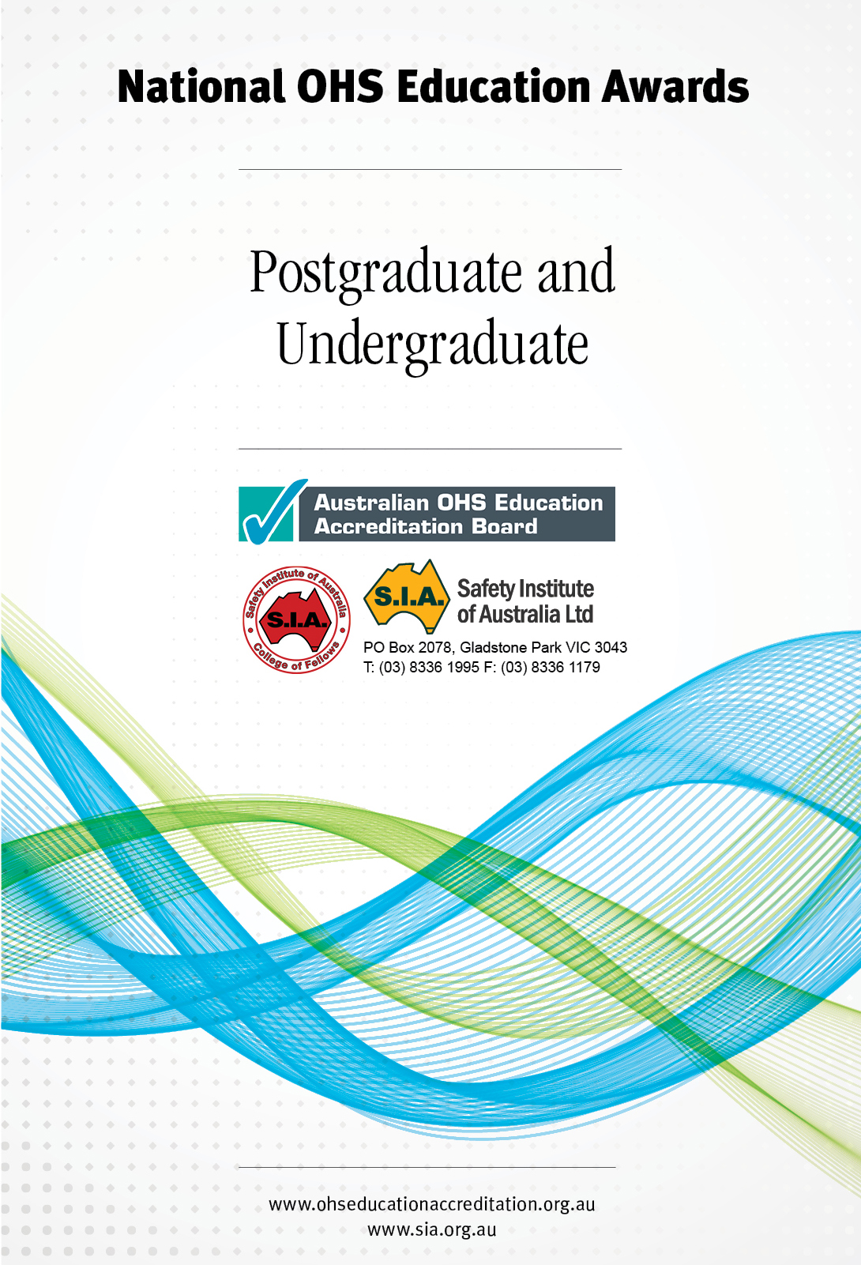

Add College of Fellows logo

**Purpose**

The Safety Institute of Australia together with the Australian OHS Education Accreditation Board presents three annual education awards. The purpose of these awards is to provide an opportunity for students studying occupational health and safety at university level, and demonstrating high levels of achievement and initiative, to be recognised by the Safety Institute of Australia.

These awards are not designed to recognise the highest academic achiever, but to recognise the potential in students who display consistently high academic standards, practical skills and a commitment to, and involvement in, occupational health and safety.

In offering the OHS Education Awards it is not the intention of the Safety Institute of Australia to repeat the academic process of assessment conducted by the education institution but to provide an OHS professional perspective to educational outcomes that have already been considered exceptional by their own educational institutions.

**The Awards**

There are three awards; the Eric Wigglesworth OHS Education (Research) Award, the National OHS Education (Postgraduate) Award and the National OHS Education (Undergraduate) Award. The national awards are presented at an annual awards event hosted by the SIA. The winners receive the following:

***Eric Wigglesworth OHS Education (Research) Award***

Commemorative medal (and certificate)

Professional Development Fund to the value of $5000

Travel and accommodation from home state to the awards presentation

Membership of the SIA for one year

Plaque to the educational institution.

***National OHS Education (Postgraduate) Award***

Commemorative medal (and certificate)

Professional Development Fund to the value of $2000

Travel and accommodation from home state to the awards presentation

Membership of the SIA for one year

Plaque to the educational institution.

***National OHS Education (Undergraduate) Award***

Commemorative medal (and certificate)

Professional Development Fund to the value of $2000

Travel and accommodation from home state to the awards presentation

Membership of the SIA for one year

Plaque to the educational institution.

This document provides information on the **National OHS Education Awards.** Information on the Eric Wigglesworth OHS Education (Research) Award is provided in a separate document.

**Selection Criteria for SIA National OHS Education Awards**

These awards are evaluated based on the program coordinator’s nomination, the student’s response to the questionnaire including evidence provided by the student. An interview may also be conducted by the selection panel.

Candidates shall be nominated by their university.

The judging for the National OHS Education Awards is based on the criteria of:

* Technical and theoretical knowledge
* Ability to access, analyse and evaluate information
* Ability to solve problems related to OHS
* Communication skills to transmit knowledge, skills and ideas
* Demonstrated application of knowledge and skills in practical situations.

**Eligible Programs**

Eligible programs are defined as a sequence of study provided by an accredited Higher Education institution where OHS as defined in the OHS Body of Knowledge constitutes a major study and results in the awarding of a bachelor degree, graduate diploma or masters (course work) qualification.

**Selection Process**

1. Program coordinators are invited to nominate one graduate from each of their eligible programs in the previous year, who they consider meet the criteria of the award.

2. Program coordinators complete the nomination form provided outlining the required information and forward to the nominated address

3. Nominated graduates are then sent a letter by the Accreditation Board advising that they have been nominated.

4. Nominee then completes the Student Questionnaire sent by the Accreditation Board which is to be returned within 3 weeks.

5. The nomination form and the student questionnaire are considered by the Education Award Panel. The panel consists of three persons as nominated by the Accreditation Board and the SIA College of Fellows with the panel comprising two OHS educators and one practicing OHS professional at the Fellow or Chartered Fellow level.

6. An interview of short-listed candidates may be conducted.

7. The panel determines the winner for each of the two Awards. The panel’s decision is final.

8. All nominees receive a letter of achievement from the Accreditation Board and the SIA College of Fellows.

9. The Awards are presented at a SIA National Awards Event.

10. Winners of awards are publicised in SIA and Accreditation Board publications and the respective web sites.

**SIA NATIONAL OHS EDUCATION MEDAL (Undergraduate)**

**NOMINATION FORM**

*In offering the OHS Education Award it is not the intention of the Safety Institute of Australia to repeat the academic process of assessment conducted by the educational institution but to provide an OHS professional perspective to education outcomes that have already been considered exceptional by their own educational institutions.*

***To be completed by the Program Coordinator***

Please forward the completed nomination form to the following address by   
**30th September 2014.**

.

**Australian OHS Education Accreditation Board**

***registrar@ohseducationaccreditation.org.au***

**or**

**PO Box 2078 Gladstone Park**

**Victoria 3043**

Any questions or queries should be directed to

Pam Pryor, Registrar, Australian OHS Education Accreditation Board, *registrar@ohseducationaccreditation.org.au*

**Education Institution:**

**Academic Unit:**

**Program: ❒ Bachelor Degree**

**Program Title:**

**Program Coordinator:**

Name:

Phone no:

Email:

**Student nominated:**

Name:

Phone:

Postal address:

Email:

***Reasons for nomination:*** *The nominating program coordinator is requested to provide comment as related to the student in the following areas.*

|  |  |  |
| --- | --- | --- |
| **Criteria** | | **Explanatory Comment** |
| Technical and theoretical knowledge | * *Demonstrable familiarity with and understanding of a broad range of concepts within the OHS Body of Knowledge with depth in some hazard areas* |  |
| Ability to access, analyse and evaluate information | * *Access, critically evaluate and analyse information from a range of sources to complete OHS activities* |  |
| Ability to solve problems related to OHS | * *Apply information gathering and critical thinking skills to identify and analyse sometimes complex problems* * *Generate practical evidenced informed solutions to OHS problems taking account of legislation and industry standards and justify the proposals* |  |
| Communication skills to transmit knowledge, skills and ideas | * *Select and appropriately apply a broad range of communication skills and formats to explain technical information and concepts suitable for workplace audiences* |  |
| Demonstrated application of knowledge and skills in practical situations | * *Recognise the implications for practice of different work environments, work and organisational cultures* * *Identify the leadership, management and support systems and processes required to ensure that recommended controls are effective* |  |
| **Further comments** | | |

**Signature Program Coordinator**

**SIA NATIONAL OHS EDUCATION MEDAL (Postgraduate) – NOMINATION FORM**

*In offering the OHS Education Award it is not the intention of the Safety Institute of Australia to repeat the academic process of assessment conducted by the educational institution but to provide an OHS professional perspective to education outcomes that have already been considered exceptional by their own educational institutions.*

***To be completed by the Program Coordinator***

Please forward the completed nomination form to the following address by   
**30th September January 2014.**

**Australian OHS Education Accreditation Board**

***awards@ohseducationaccreditation.org.au***

**or**

**PO Box 2078 Gladstone Park**

**Victoria 3043**

Any questions or queries should be directed to

Pam Pryor, Registrar, Australian OHS Education Accreditation Board, *registrar@ohseducationaccreditation.org.au*

**Education Institution:**

**Academic Unit:**

**Program:** ❒ Graduate Diploma ❒ Masters (course work)

**Program Title:**

**Program Coordinator:**

Name:

Phone no:

Email:

**Student nominated:**

Name:

Phone:

Postal address:

Email:

***Reasons for nomination:*** *The nominating program coordinator is requested to provide comment as related to the student in the following areas taking account of the qualification level completed by the nominee*

| **Criteria** | **AQF 8 (Grad Dip)** | **AQF 9 (Master)** |  |
| --- | --- | --- | --- |
| Technical and theoretical knowledge | * *Demonstrated advanced theoretical and technical understanding and ability to systematically apply a broad range of concepts and sub concepts of the OHS Body of Knowledge* | * *Demonstrated advanced theoretical and technical understanding and ability to draw together relevant concepts and sub concepts from the OHS Body of Knowledge* |  |
| Ability to access, analyse and evaluate information | * *Access and critically evaluate information from a range of sources to transform information as part of an activity* | * *Access, critically evaluate and reflect on complex information from a range of sources to generate complex ideas and concepts* |  |
| Ability to solve problems related to OHS | * *Apply information gathering and critical thinking skills to identify and analyse complex OHS problems and generate, prioritise and justify evidence-informed solutions* | * *Apply information gathering and critical thinking skills to identify and analyse complex OHS problems, generate, prioritise and justify evidence-informed solutions taking account of legislation, industry standards and business considerations* |  |
| Communication skills to transmit knowledge, skills and ideas | * *Interpret and tailor information and select and apply appropriate strategies to communicate technical and theoretical concepts in a clear, concise and logical manner giving under pinning rationale* | * *Interpret and tailor technical information, complex ideas and theories to communicate knowledge and ideas to a range of specialist and non-specialist audiences* |  |
| Demonstrated application of knowledge and skills in practical situations | * *Demonstrated capacity for planning and making independent judgements in a range of OHS technical and management activities* | * *Demonstrated project management skills, autonomy and creativity* |  |

|  |
| --- |
| **Further comments** |

**Signature Program Coordinator Date**